

**Product Dissection for Facebook – (Research Work)**

**Company Overview:**

Facebook is an online social and social networking service owned by American technology giant Meta Platforms. Created in 2004 by Mark Zukerberg with four other Harvard college students and roommates  [Eduardo Saverin](https://en.wikipedia.org/wiki/Eduardo_Saverin), [Andrew McCollum](https://en.wikipedia.org/wiki/Andrew_McCollum), [Dustin Moskovitz](https://en.wikipedia.org/wiki/Dustin_Moskovitz), and [Chris Hughes](https://en.wikipedia.org/wiki/Chris_Hughes), its name derives from the Face book directories often given American university students. Membership was initially limited to Harvard students, gradually expanding to other North American university students. Since 2006, Facebook allows everyone to register from 13 year old(or older), except in the case of the handful of nations, where the age limit is 14 years. As of December 2022, Facebook claimed 3 billion monthly active users.

Facebook can be accessed from devices with internet connectivity, such as personal computers, tablets & smartphones. After registering , users can create a profile revealing information about themselves. They can post text, photos & multimedia which are shared with any other users who have agreed to be their “friend” or, with different privacy settings, publicly. Users can also communicate directly with each other with Messenger , join common-interest groups and receive notifications on the activities of their Facebook friends & pages they follow.

**Product Dissection & Real-World Problems Solved by Facebook:**

Facebook, global tech giant, has effectively managed to solve real life problems and has opened new scope of sharing and earning also. Instagram's ingenious engagement features, such as likes, comments, and personalised content recommendations through the "Explore" feature, have revolutionised how users interact with content. By addressing the challenge of content overload, Instagram curates relevant content, helping users discover new accounts, posts, and trends tailored to their interests.

Facebook enables facebooker to upload faithful and effective videos that circulate the knowledge sharing process. Facebook provides very simple interface that is easy to understand and access.

Facebook’s features address real-world challenge by empowering users with privacy controls, implementing robust content moderation, facilitating real-time communication, personalizing content delivery, streamlining event management, and support local commerce.

**Case Study: Real-World Problems and**

**Instagram's Innovative Solutions**

**Facebook,** a leading social media platform, has not only revolutionised the way we share & consume content but has also addressed significant real-world challenges through its innovative features.

**@ Problem 1: Privacy Settings –**

**Real-life Challenge –**

As social media platforms evolved, concerns about user privacy & data security became paramount. Users wanted control over what information they shared and with whom.

**Facebook’s Solution –**

**Facebook,** introduced robust privacy settings, allowing users to customize the visibility of their posts, control friend requests, and manage who can see their personal information. This feature empowers users to tailor their online presense according to their comfort levels.

**@ Problem 2: Content Moderation –**

**Real-life Challenge –**

With the massive amount of content shared daily, maintaining a safe & respectful environment is crucial. Addressing issues like cyberbullying , hate speech and inappropriate content is constant challenge.

**Facebook’s Solution –**

The platform employs advanced content moderation algorithms and user reporting mechanisms to identify & remove content that violates community standard. This proactive approach helps create a safer & more inclusive online space.

**@ Problem 3: Real-time Communication –**

**Real-life Challenge –**

Connecting with friends & family across the globe in real-time can be challenging , especially considering time zone difference & busy time

**Facebook’s Solution –**

Features like Messengers & video calls provide instant communication, enabling users to connect with others regardless of geographical barriers. This fosters a sense of closeness & immediancy , addressing the challenge of staying connected in fast paced world.

**@ Problem 4: News Feed Algorithm –**

**Real-life Challenge –**

Information overload is a common problem on social media platforms, making it difficult for users to find content that is relevant & interesting to them.

**Facebook’s Solution-**

The News Feed algorithm uses machine learning to prioritize content based on user preferences, engagement history , & relationships. By personalizing the content shown to each user, Facebook addresses the challenge of information overload & enhance the overall user experience.

**@ Problem 5: Event Management –**

**Real-life Challenge –**

Coordinating events & gathering with friends can be cumbersome especiallywhen dealing with multiple schedule & preferences.

**Facebook’s Solution-**

The Events feature allows users to create , share, & manage events seamlessly. Users can easily invite friends & receive updates, streamlining the process of event planning & attendance coordination.

**@ Problem 5: Marketplace –**

**Real-life Challenge –**

Buying & selling items locally can be challenging , especially without a centralized platform for discovery.

**Facebook’s Solution-**

The Marketplace feature provides a platform for users to buy & sell items within their local communities. This addresses the challenge of local commerce by facilitating transactions & connections between users with mutual interest.

**Conclusion-**

In summary, Facebook’s innovative solutions to real-world challenges include empowering users with privacy controls, implementing robust content moderation, facilitating real-time communication & supporting local commerce . .These features collectively contribute to more user-friendly & secure social media experience.

**Top Features of Facebook –**

**1.News Feed-**

The central features displaying a personalised stream of updates, posts & activities from friends , pages & groups that user follows.

Driven by an algorithm that prioritizes content based on user enagagement & preferences.

**2.Profiles –**

User profiles serve as personal spaces where individuals share information about themselves, including photos, updates & personal details.

**3. Timeline –**

A chronological display of user’s post & activities,providing a historical view of their interaction on platform.

**4. Friend Request & Friend Lists –**

Users can connect with others by sending friend request. Friend list allows user to categorize their friends into groups with varying levels of access to posts.

**5. Messenger-**

A standalone messenging app integrated with Facebook, enabling users to send text messages & make voice & video calls & share multimedia.

**6.Pages –**

Used by businesses, organizations & public figures to create a public presence on Facebook. Pages allow entities to share updates, interact with followers & build a community.

**Schema Description –**

The Schema for Facebook involves multiple entities that represent different aspect of platform. These entities include Users, Posts, Comments, Likes, Followers, Hashtags, and more. Each entity has specific attributes that describe its properties and relationships with other entities.

**1.User –**

* UserID (Primary Key) – A unique indentifier for each user.
* Username – The choosen name for user account.
* Email- Email address of user.
* Last login – Last Login date of user.
* ProfilePictureURL- Profile picture of user that represent user.

**2. FriendshipID(Primary Key)-**

* UserID1(Foreign Key referencing user. UserID),
* Status – Status of their friend request (pending, accepted, declined)
* Request Date – Request date on which user send friend request to known person.

**3. Post –**

* PostID (Primary Key)- Unique id for each post by user
* UserID – Foreign key referencing User.UserID
* Privacy Setting – It may be public, friends, only me
* ImageURL – URL of image

**4. Comment –**

* CommentID – Unique Id for each comment
* PostID – foreign key referencing to user.userID
* CommentDate – Date of comment
* Like count – like for the comments

**5.Like –**

* LikeID - Primary key for like
* PostID – Foreign key referencing Post.PostID
* Like Date – like date on which post is liked by another user.

**6.Message –**

* MessageID – Primary Key for the each message.
* SenderID – Id of a sendor. Foreign key referencing user.userID
* ReceiverID – Foreign key referencing user.userID
* ReadStatus – Status of message (seen or not)

**7**. **Group** –

* GroupID – Primary key for group id
* CreatorID – Foreign key referencing User.UserID
* CreationDate – Creation date for group.

**RELATIONSHIP –**

* **Users & Friendship –**

One to many relationship between Users & Friendship ( a user can have many friendship.)

* **Users & Posts –**

One to many relationship between Users & Posts (a user can create multiple posts.)

* **Posts & Comments –**

One to many relationship between posts & comments (a post can have multiple comments.)

* **Users & Messages-**

One to many relationship between Users & messages (a user can send/Receive multiple messages)

* **User and Groups –**

Many to many relationship between users & groups through Groups.

**ER** **Diagram** :

Let’s create ana ER diagram, that reflect the relationship & attributes of entities within the Facebook’s schema. This ER diagram will showcase the pictorial relationship between schemas within the structures. By employing this diagram, you will gain & clearer grasp of the intricate interactions & connections that define the platforms dynamics

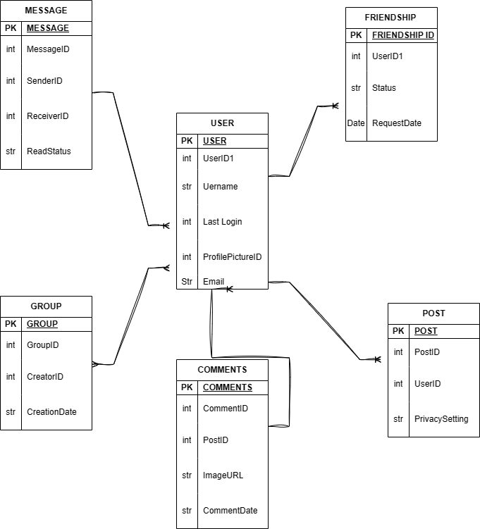

**CONCLUSION** :-

The product dissection reveals Facebook’s intricate design aimed at creating a dynamic & secure social environment.Its success lies in addressing real-world challenges, providing innovative solutions, and structuring data in a way that supports a seamless user experience.

This dissection not only provides insights into Facebook’s current state but also lays the groundwork for understanding the platform’s adaptability & potential future enhancements